MAP 01:- NYS Hudson River Counties

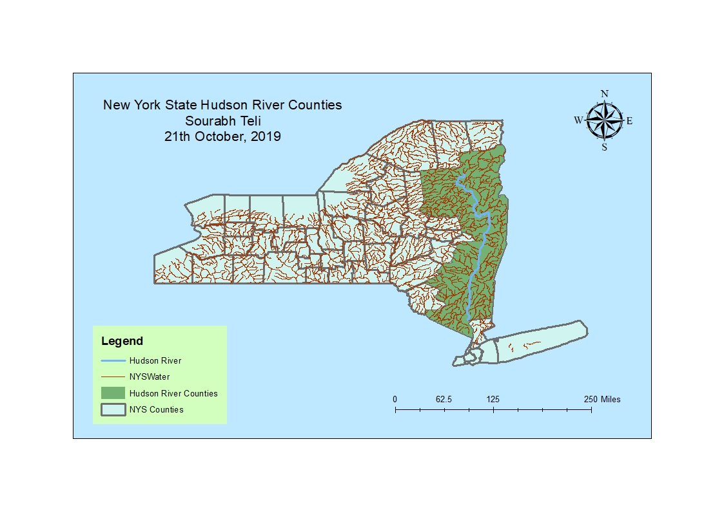

MAP 02: Westechester Gas Stations